1. What is MySQL? Demonstrate with stepwise screenshots that how you use from phpmyadmin tool?

Step 1 : Install xampp and run the components

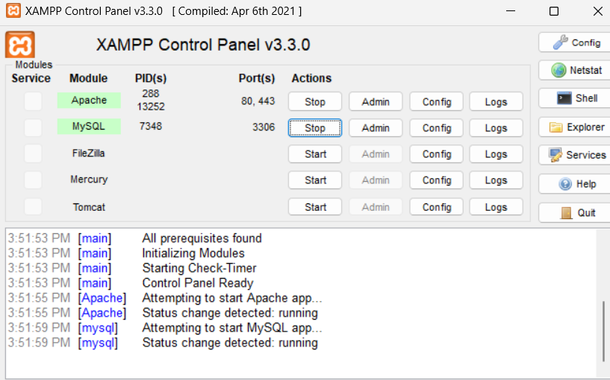

Step 2 : Click on admin of “Mysql”

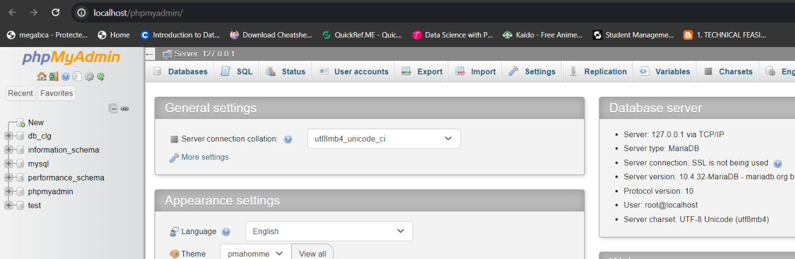

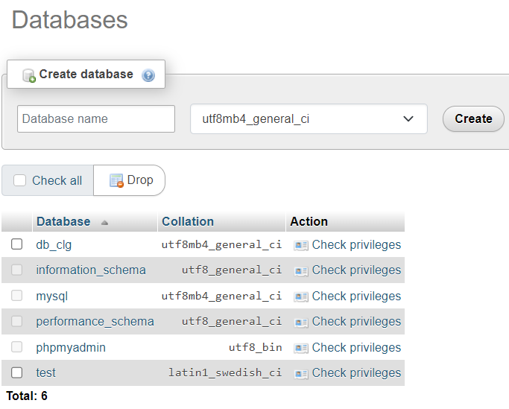

Step 3 : Click on “new” to create new database.

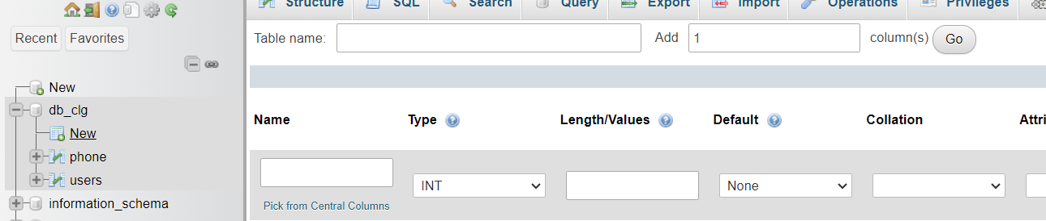Step 4 : Click on created db then create new table as needed.

Step 5 : We can do following things :

- Change structure of table

- Use command line

- Export and import

 - Change privilege

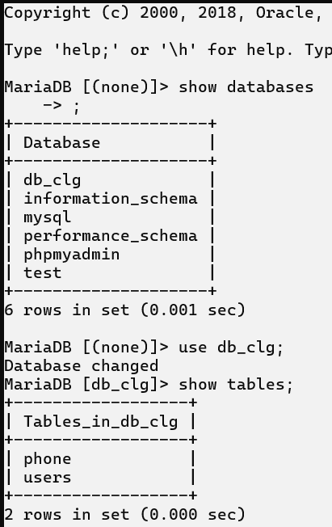q2